We used the best performance validation accuracy of the exercise 1
units1 | units2 | epochs | batchsize | lr | optimizer | Accuracy
256 | 128 | 10 | 32 | 0.001 | Adam | 0.8825
Let’s try to improve it!

Hypothesis 1 – Dropout
“Dropout reduces overfitting and improves validation accuracy”
 | Baseline | Dropout 0.5 | Dropout 0.3 | Dropout 0.8 | Dropout 0.1
Validation Accuracy, epoch 10 | 0.8825 | 0.8796 | 0.8865 | 0.8769 | 0.8824
Loss train, epoch 10 | 0.2342 | 0.282 | 0.2655 | 0.3561 | 0.2394
Loss test, epoch 10 | 0.3321 | 0.3429 | 0.335 | 0.3598 | 0.3377

Alright, we can see that the validation accuracy increases slightly with the addition of dropout. For the most part, it performs similarly to the baseline, and in some cases, it is even slightly worse. We cannot conclude that simply adding dropout will improve validation accuracy.
Looking at overfitting, we can see that it is indeed reduced. This is evident from the fact that the dropout loss decreases more slowly than the baseline. Eventually, both losses reach approximately the same value, but the baseline approaches this final number several epochs earlier than the dropout model.

Hypothesis 2 – BatchNorm
BatchNorm causes for a stabler training and quicker conversion of the data
 | Baseline | Normalization | Normalization + dropout 0.3 | Normalization + dropout 0.5
Validation Accuracy, epoch 10 | 0.8825 | 0.8846 | 0.8815 | 0.8873
Loss train, epoch 10 | 0.2342 | 0.2153 | 0.2412 | 0.2658
Loss test, epoch 10 | 0.3321 | 0.3464 | 0.3420 | 0.3319

Okidoki, we can see that the train loss decreases faster than the baseline. The endpoint at Epoch 10 shows an improvement of around 0.02 compared to the baseline. I also tried to combine normalization and dropout to see if it would have the same effect as using only normalization, but unfortunately this was not the case, and it performed slightly worse.
We also observe a slight increase in validation accuracy in most of the test cases, which provides indirect evidence that the overall generalization performs better than the baseline.
Looking at the test loss, we can see that normalization does not perform as well, as it results in a slightly higher loss score compared to the baseline.

Hypothesis 3 - convolutional and pooling layers
“Adding convolutional and pooling layers improves the accuracy greatly”
 | Baseline | CNN epoch 10 | CNN epoch 20
Validation Accuracy | 0.8825 | 0.8883 | 0.9079
Loss train | 0.2342 | 0.2451 | 0.1969
Loss test | 0.3321 | 0.3126 | 0.2751

With the CNN in place, I expected a lot from it due to the lesson about CNNs. I expected that we could easily achieve a validation accuracy above 0.900. While the CNN with only 10 epochs improved the model slightly, it did not give the great results I was expecting. Without tuning too much and making it harder to compare with the previous results, I decided to use 20 epochs for a second run.
That worked out as expected. The CNN with 20 epochs performed much better and achieved the expected performance. A lot of new layers were added to the Neural Network, and this clearly had an impact on the model. We see improvements in all three measurements: validation accuracy (finally above 0.900), a significant decrease in the train loss, and also a decrease in the test loss, which is a very good result.

Visuals
Dropout
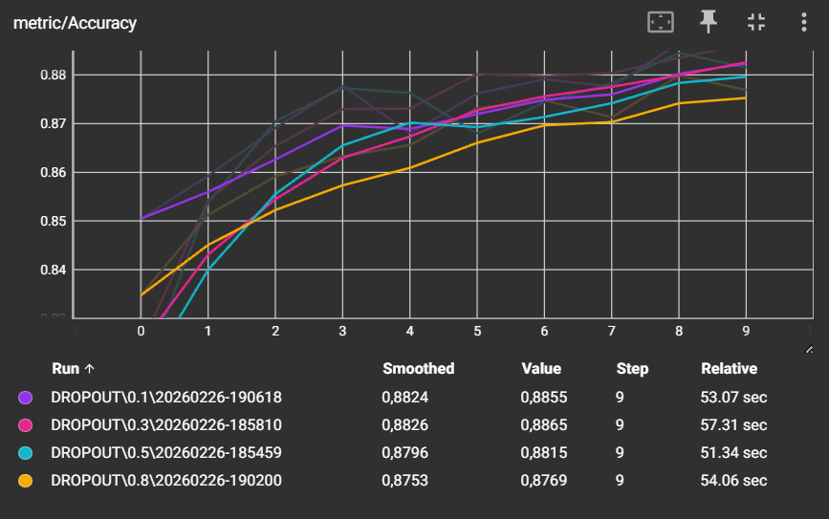
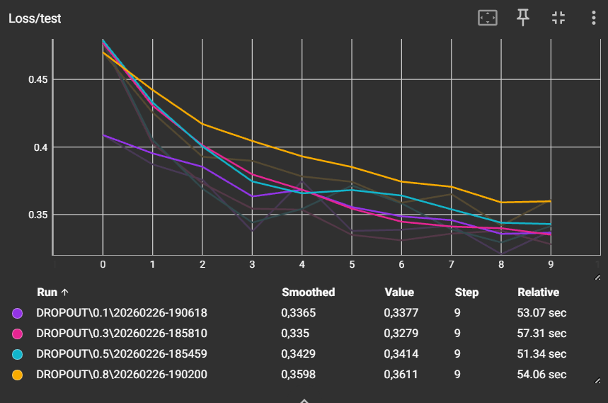
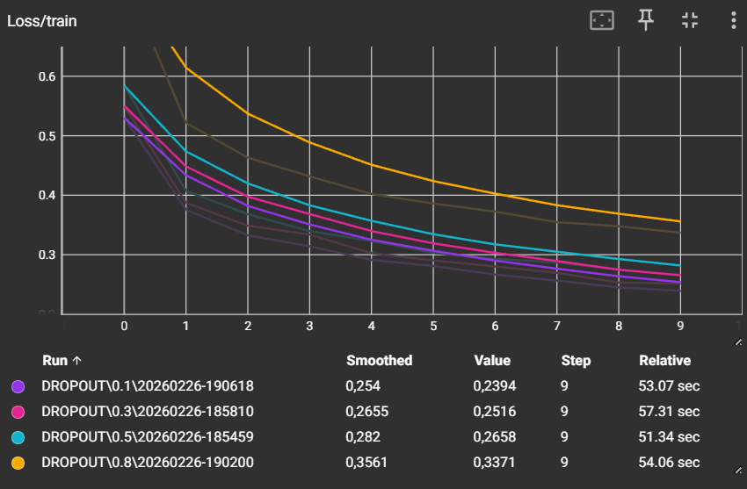

Batchnorm
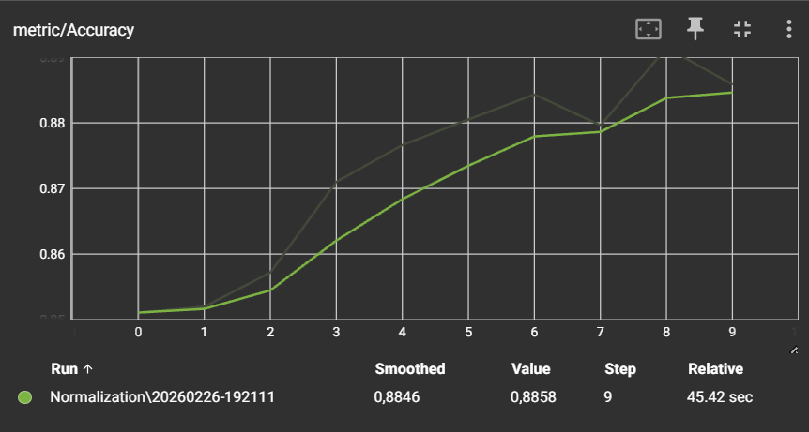
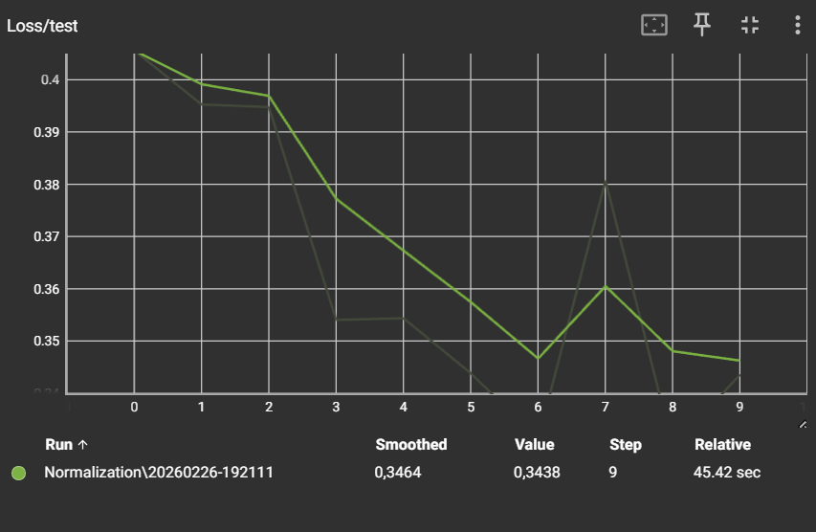
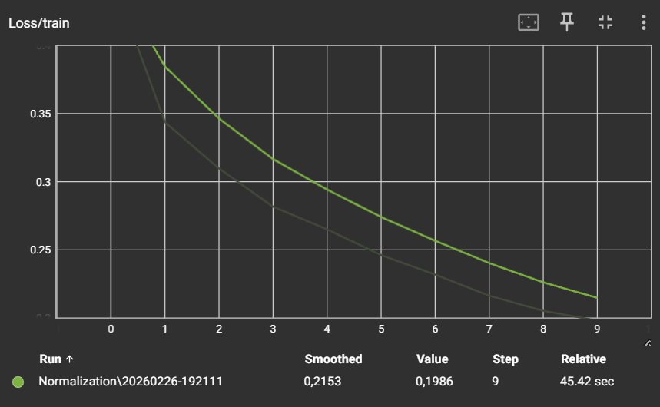
Batchnorm + Dropout
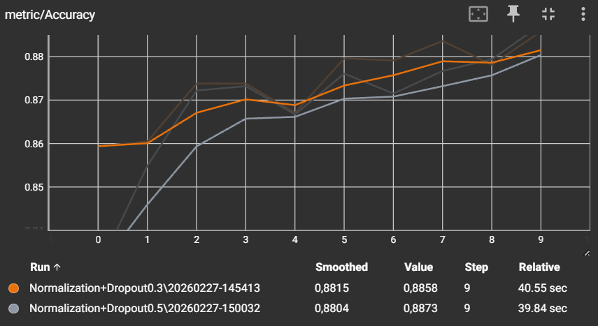
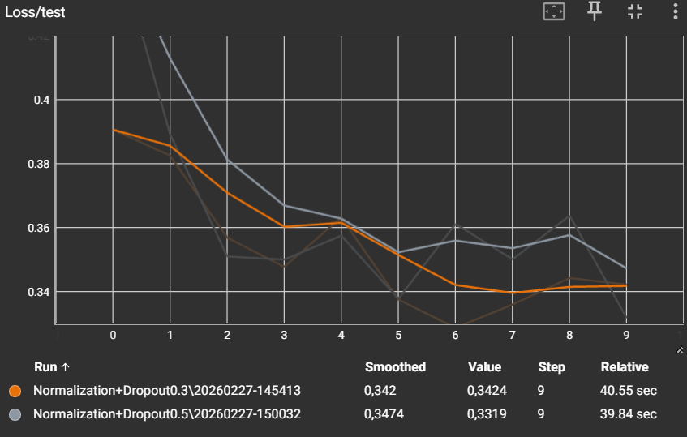
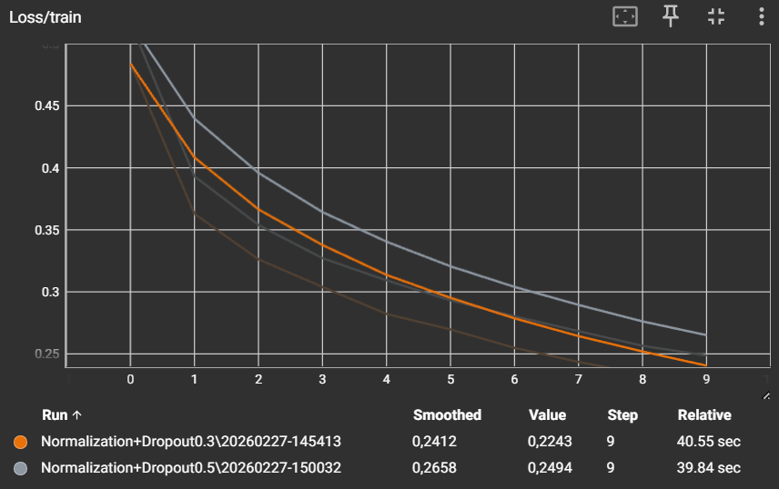
CNN
